LOGO MOJO

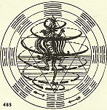
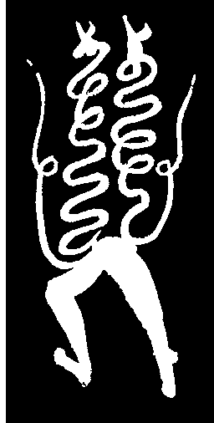
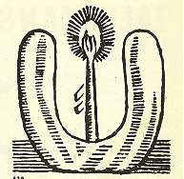
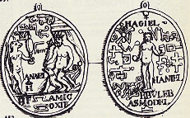

Talismans and charms are first and foremost means of practical magic enabling humans to communicate, influence or control the workings of the invisible forces of nature for their own benefit. These may include what we in the West would call spirits or demons, but oftentimes it simply refers to the life force, vital essences or animate processes that all things possess, which is a far cry from most Western conceptions of the spirit world.

Talismans are often used to cure sickness, bless marriage, ease childbirth, protect household from fire, to stave off pestilence and misfortune, guard against calamities, invite good fortune, provide the strength, harmonize polarities, influence the weather, control ones emotions, etc. in short, talismans and charms are impersonal repositories of power. Talismans gain their power by simple convention (and general agreement that a given form is simply naturally endowed with power), through ritual, contact with other powerful people things or forces (contagion) or through metaphor. Very often talismans establish complex connections between forces, things and attributes drawing together concepts that we in the west might not acknowledge is having any connection whatsoever.

In their original form many talismans are highly impermanent and perishable. These can consist of diagrams drawn in the dust or dirt with a stick or finger other times they may be written on paper and burnt as offerings to the forces. They may consist of sand paintings, tattoos, and amulets, may be worked into the designs of clothing, architecture or sculpture, may be carried or eaten or buried. The varieties of compositions that many cultures use is enormous, ranging from the spontaneity of trance-drawings to the meticulous draftsmanship of pseudoscientific diagrams and magic charts. Nearly every culture has developed some form of talismanic image. It may be argued that commercial logos serve a similar purpose. They embody the “elan vital” of the corporation, seek to influence consumers and investors and financial markets. Ordinary people may find a sense of well being (comfort, confidence, coolness) provided by corporate talismans as it helps them stave off the unseen forces of aging, decrepitude or foolishness, while surrounding them with the aura of such positive spirits as sophistication, coolness, belonging, power or wealth.

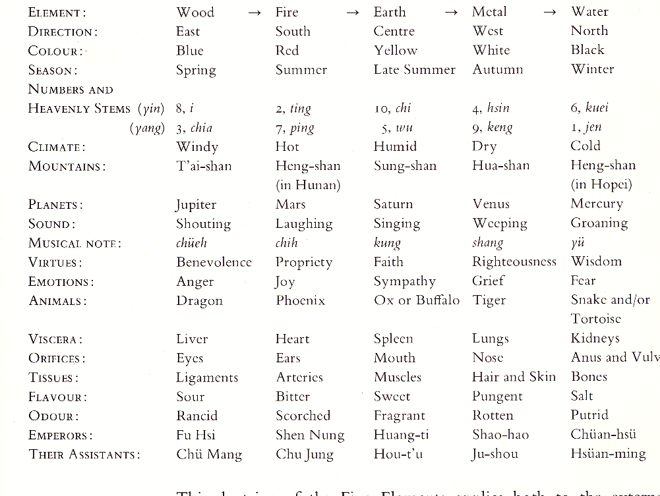
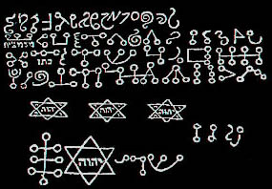Some examples of talismanic associations
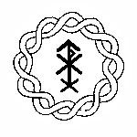
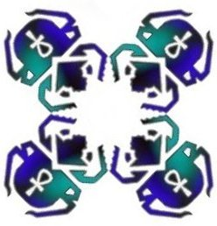
Procedures:
1. Identify an unseen aspect or force that you posses or that effects you, that you would like to influence in some way (attract, repel, alter). Try to be as specific, honest and self-insightful as possible rather then vague or arbitrary.
2. Start with your three initials. Abstract the letterforms as the beginning of your composition. Lay out the forms on a grid and experiment with different symmetries on various axes.
3. We will be executing these in the medium of woodcut using a 5”X5” square. Designs that are shape oriented and use positive/negative space relationships are more likely to be successful then linear designs.
4. Develop or invent the proper presentation for your print(s). You can print onto a variety of surfaces (paper, cloth, wood, etc.), in a variety of colors, in any arrangement, any number of times. The repeatability of the print is important! Use a presentation format that is consistent with your image and its content. Find a way to get your talisman out in the world rather then just centered on a piece of paper and tacked to the wall. Be inventive!

Hints:
- Because talismans are powerful they often use occult (hidden) imagery. Find ways of meaningfully abstracting or personalizing your source material so that it is not “transparent”
- Do lots of visual as well as standard research to get ideas for your choice of imagery
- Don’t use or radically transform cliché symbols
- The first, and perhaps most fun form of research, is to get ideas from friends and peers. Discuss your ideas!



