Assignment 4
A Method to the Madness

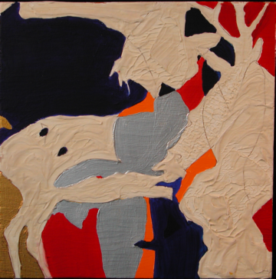
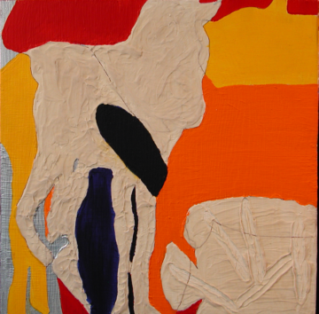
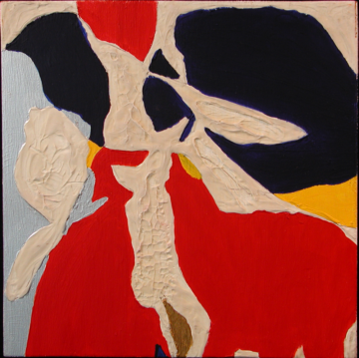

GOALS:
To demonstrate problem finding, creative thinking and critical analysis as applied to a practical studio situation.

FIELDWORK 1
Indentify 3 aesthetic issues that interest you. These can deal narrowly with the aesthetics of a particular artistic medium or discipline (ex. Does mixing color really yield more pleasing results then working from the tube? Why do found object sculptures often evidence extreme repetition?), or your research may focus on broader issues of cultural aesthetics (ex. deconstrcting manga- Why the crazy hair? Or, Commodification- How can a mass produced and mass marketed product project a sense of individual expression? or "greening" of corporate America- How does Shell’s cooperate identity differ from BP’s/ How are they similar? How do they counter the un-American (both are foreign owned) and un-green realities of their businesses?) Turn these into three artistic/design questions (problems) that are sufficiently narrow in scope. With your instructor select one question to serve as the focus of this assignment.
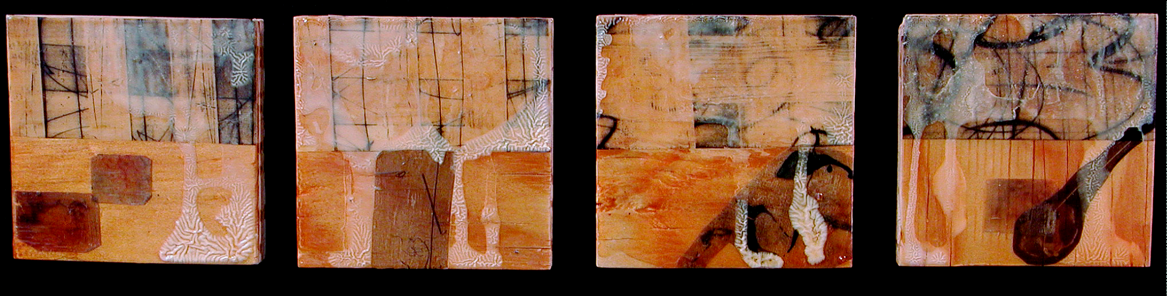

FIELDWORK 2
  - Type up 3 research methodologies that deal with or “get at” the question- not answer it. As part of each methodology you must define the scope, the approaches, strategies and critical framework that seems the most promising and establish some criteria by which you would be able to identify successful, or novel solutions. Your methodology should include media, scale, materials, technique(s) and a plan for how you will conduct visual research. Type up your 3 methodologies in 1 to 2 pages. Make sure to address all the points above. You will go over it one-on-one with the instructor and turn it in.

- PROCEDEURE:
Create three related artworks that are the result of your research. Keep in mind that these will most likely be related (they are after all the result of the same strategy) and should be "variations on a theme". Do not "go commando" and abandon the support of your research strategy and completely switch gears in the process. The constraints that you set are in place to keep you focused and enhance (NOT curtail) creativity. You will present all three pieces together for critique.

HINTS:
- Develop a methodology that utilizes various forms of visual research and has iteration built in. In general a larger resource pool is better than a pallry one.
- Consider working in parallel, all three pieces at the same time, rather than serial due to the time constraints.
- Keep things manageable but not simplistic.
- Challenge yourself by not using all studio practices with which you are familiar. Shift a couple of them (work with a new material or technique or support, develop new routines, or work with unfamiliar genres or at a new scale.)
- Don’t however, use ALL new studio practices
- DON’T COMPLETELY ABANDON YOUR METHODOLOGY. It’s ok to be a little flexible, but the structure and constraints really are helpful.



